
Blue Team Shooting Sports A.S.S.S. June 9th, 2026
COURSE DESIGNER: Ike Starnes

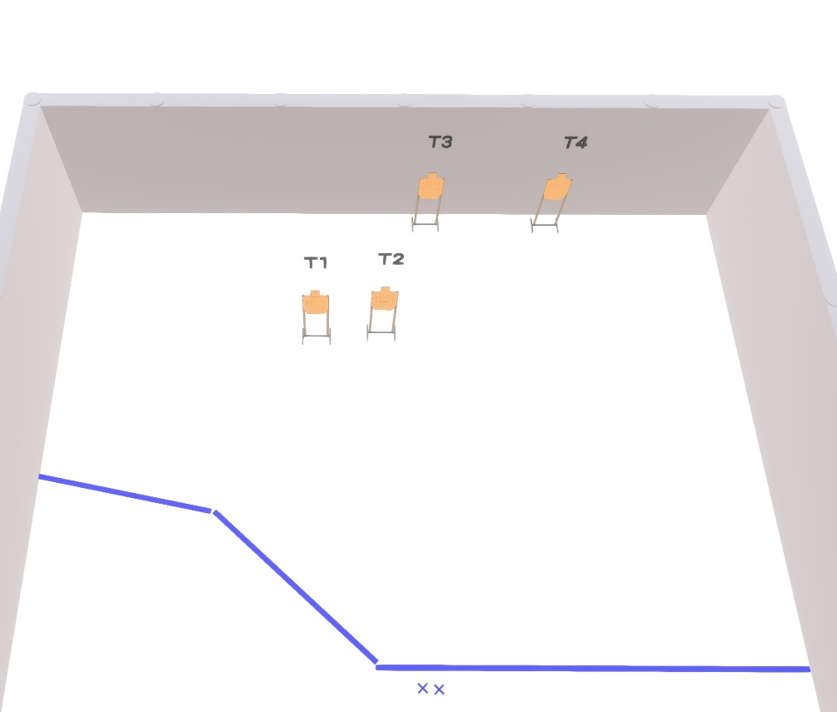

Written Stage Briefings:

Stage 3 – Seriously? - is a 12-round, 60 point, Virginia Count Course. There are 4 cardboard targets. The best 3 hits per cardboard target will be scored.
Handgun start position Both feet on left Xs. The handgun is loaded and holstered, wrists below belt.
PCC start position Both feet on left Xs. PCC is loaded with stock touching belt.
On the audible start signal, from within the shooting area, engage targets T1-T4 with only 2 rounds each, then make a mandatory reload and engage targets T1-T4 with only 1 round each weak hand / shoulder only.

